Arts & Sciences

New Faculty Handbook

2021-2022

Contents
Yakima Valley College 2021-2022 Academic Catalog 3
Campus Directory 3
Academic Calendar 3
Arts & Sciences Org Chart 5
YVC Organization Chart 6
Arts & Sciences Directory 7
Syllabi Tips 9
Counseling/Advising Center Info 11
Arts and Sciences Absences, Leave Requests and Cancelled Classes 11
Technology Services 13
Canvas 14
2021-2022 Divisional Committee Representatives 15
Department Schedulers 15
Observations and Student Evaluations 16

Welcome to YVC! The Arts & Sciences Division is excited to have you join us and is looking forward to a wonderful year! While you may have many questions and may be overwhelmed by the information you receive, this handbook hopefully will become a source to answer your questions and provide you with vital information to begin your teaching journey here at YVC. For the most part, the items in this handbook are Arts & Sciences specific. Please also take some time to familiarize yourself with the New Faculty Orientation section in the Faculty and Staff portal on the YVC website.

Yakima Valley College 2021-2022 Academic Catalog
The YVC 2021-2022 Academic Catalog can be accessed from the main YVC website: http://catalog.yvcc.edu/index.php.

Campus Directory
The YVC Campus Directory can be accessed from the main YVC website: https://www.yvcc.edu/contact/#directory

Academic Calendar
The academic calendar (below) can be accessed from the following link: http://www.yvcc.edu/registration/wp-content/uploads/sites/4/2021/05/AY2021-22-Academic-Calendar.pdf
Please refer to the academic calendar when creating your class schedule and planning any personal time off.
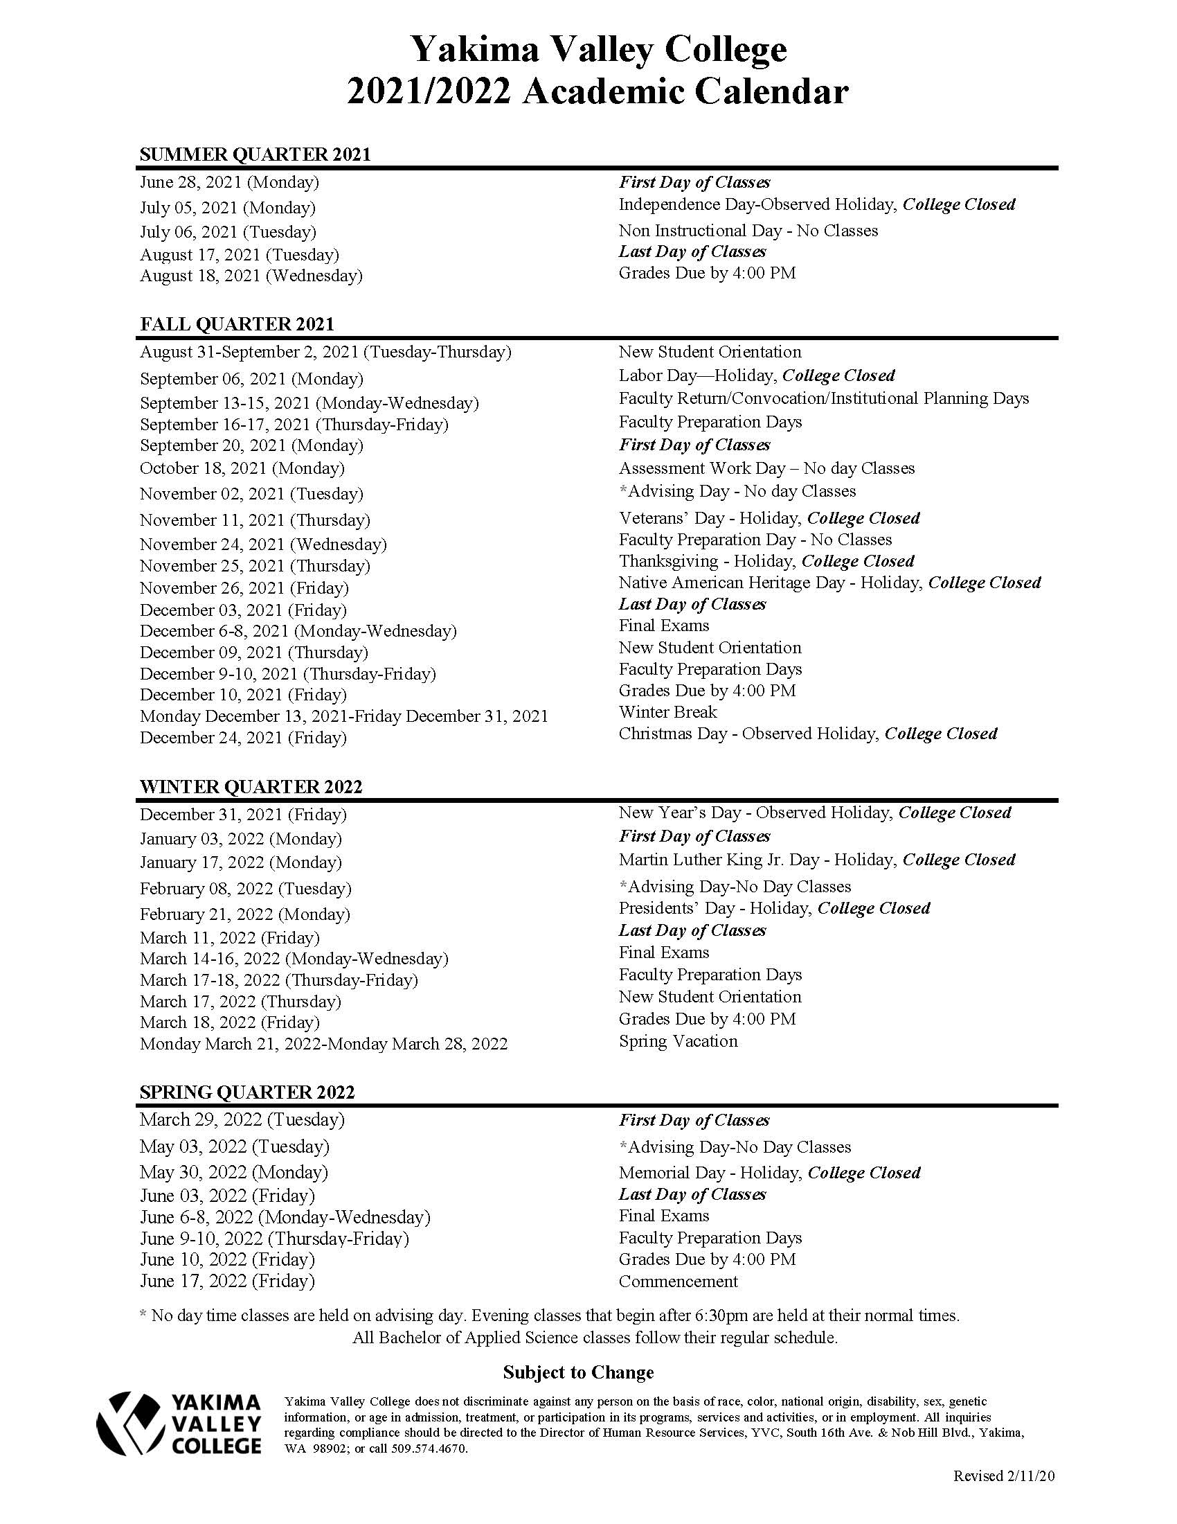

Arts & Sciences Org Chart

YVC Organization Chart

Arts & Sciences Directory

Dean of Arts & Science
Kerrie Cavaness, M. Ed.
009-125C—ext. 4871
kcavaness@yvcc.edu

Fiscal Manager
Tammera LeRoue
009-125B – ext. 4514
tleroue@yvcc.edu

Program Support Supervisor 2
Sarah Frazier
009-125A – ext. 4839
sfrazier@yvcc.edu

Secretary Senior A&S
Vanessa Tucker
009-125—ext. 4892
vtucker@yvcc.edu

Fiscal Tech 2
Cheryl Mills
009-125 – 834-4594
cmills@yvcc.edu

Program Assistant -Humanities
Gina Scribner
020-151- ext. 4881
gscribner@yvcc.edu

Secretary Senior- English & Social Studies
Kelley DiBenedetto
004-142 - ext. 4834
kdibenedetto@yvcc.edu

Secretary Senior- Math & Sciences Rebecca Sanchez
004-242—ext. 4869
rebeccasanchez@yvcc.edu

Laboratory Technician 2
Adriana Magallanes
004-204E – ext. 4578
amagallanes@yvcc.edu

Instructional Classroom Support Technician-Writing Center
John Schofield
004-125B– ext. 4829
jschofield@yvcc.edu

Instructional & Classroom Support Technician—Writing Center
Joshua Swayne
004-125 – ext. 4564
jswayne@yvcc.edu

Grandview Campus Secretary Senior
TBD
056-109 - 882-7009

Syllabi Tips

Below are important items to include in your syllabi:

- The correct course number and name (i.e. ENGL& 101)
- “Yakima Valley College” (and updated “YVC” verbiage throughout the document)
- The correct quarter/year (Fall 2020)
- Your name, direct phone number, and office location (i.e. 020-###)
- The new Institutional Assessment Statement – THIS WILL REPLACE THE COURSE ABILITIES STATEMENT

1. “Institutional Assessment Statement – In addition to the content of each discipline, YVC emphasizes the development of the following three outcomes: Communication (C), Computation/Analytical Reasoning (C/AR), and Human Relations (HR). As a student, your abilities may be assessed in one or more of these outcome areas. For further information, refer to general education outcomes in the catalog.”

- Disability Support Services - YVC is committed to providing access for all students wishing to attend its campuses and complies with Section 504 of the Vocational Rehabilitation Act of 1973 and the Americans with Disabilities Act (ADA). As part of this commitment, the college’s Disability Support Services (DSS) program works on an individual basis with qualifying students by providing appropriate classroom accommodations, access to adaptive equipment, and barrier-free facilities. http://catalog.yvcc.edu/content.php?catoid=5&navoid=322
- Plagiarism Statement – is available in the most recent Academic Catalog- may provide a link to the statement
- Objectives & Outcomes from the approved Curriculum Course Outline. These outlines can be found on the Vice President for Instruction and Student Services’ page on the YVC Faculty and Staff portal. Feel free to contact the Dean’s office for assistance.

- Faith & Conscience – To appropriately comply with the requirements of SB 5166, please include the following language in your syllabi starting Winter quarter 2020:

“Washington state law SB 5166 requires that YVC provide accommodation for student absences or significant hardships due to reasons of faith or conscience, or organized religious activities. The YVC procedure, including a form that you may use to request leave day under SB 5166, is available at this link: https://www.cognitoforms.com/YakimaValleyCollege6/AbsenceForReasonsOfFaithOrConscience . Student leave for reasons of faith or conscience must be requested by the use of this form, within the first two weeks of the quarter

Counseling/Advising Center Info

The Counseling and Advising Center provides academic advising, career planning, and personal counseling services to the YVC campus. Online services are currently available.

counseling@yvcc.edu
Yakima Office: 509.574.4956
Grandview Office: 509.882.7042

Arts and Sciences Absences, Leave Requests and Cancelled Classes

All faculty will be required to submit a Leave Request and Class Cancellation Form to the Dean’s office for any planned absences before the absence with as much lead time as possible. If you are ill or cannot teach your class for any reason, you must notify the Dean’s office and your respective Secretary Senior/Program Assistant immediately so that your class gets posted (as canceled). Upon your return, submit your Leave Request and Class Coverage Form to the Dean’s office, either electronically or through intercampus mail. Leave Requests can be found on the Staff and Faculty portal under “forms”. Your respective Secretary Senior/Program Assistant will also have the Leave Requests and the Class Coverage Forms.

Technology Services
If you are having problems with your computer or telephone, you may contact the Help Desk through the YVC Faculty and Staff portal and submit a ticket.

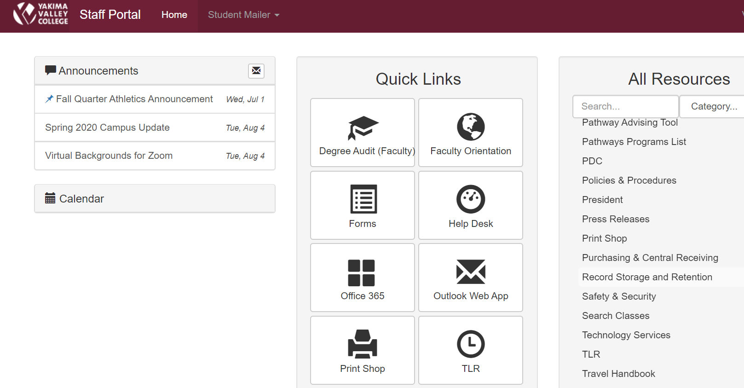

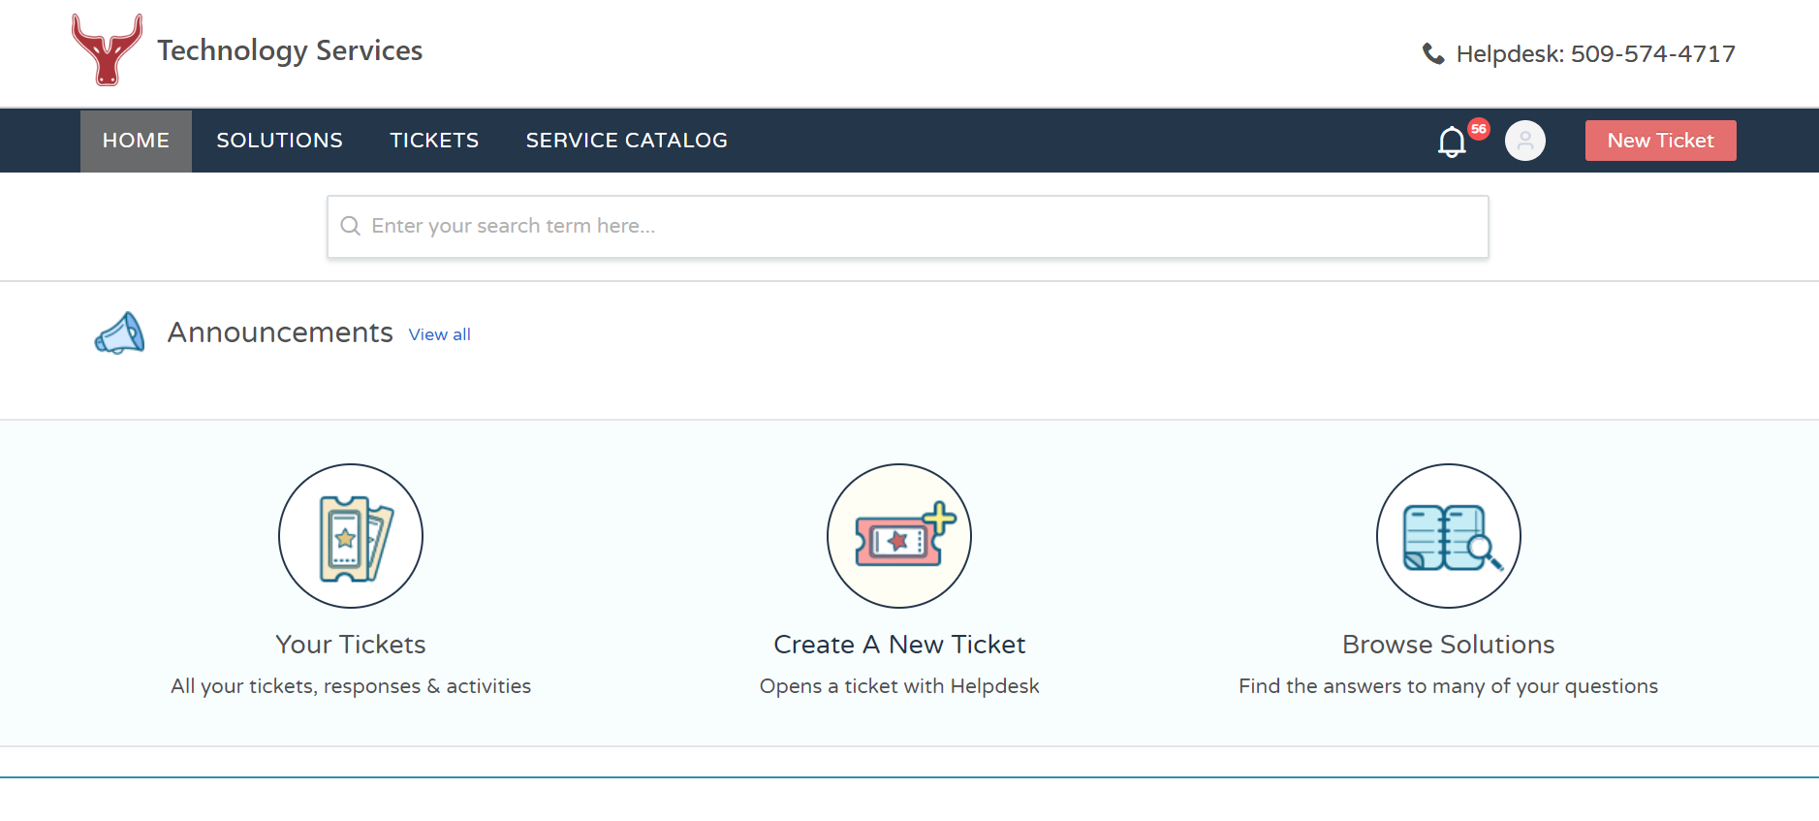

Canvas
Within the Faculty Orientation page on the Faculty and Staff Portal, you will find information on Canvas and tips on teaching online.
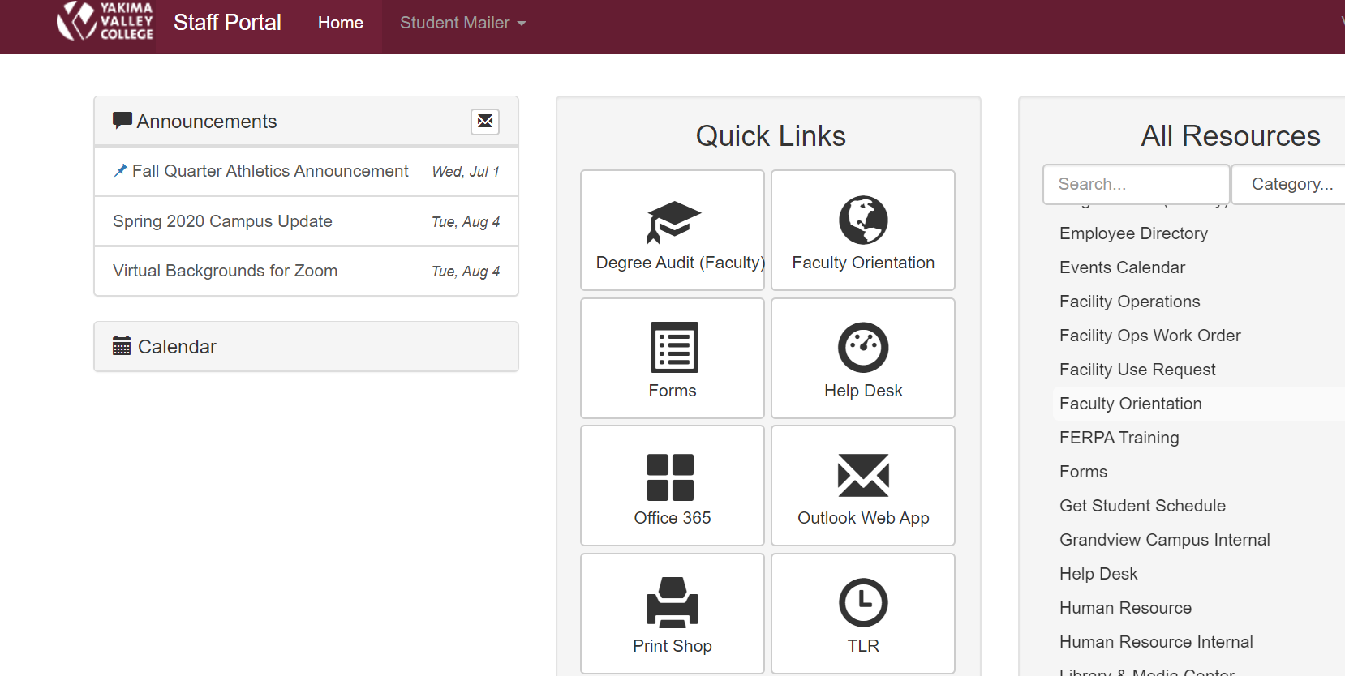
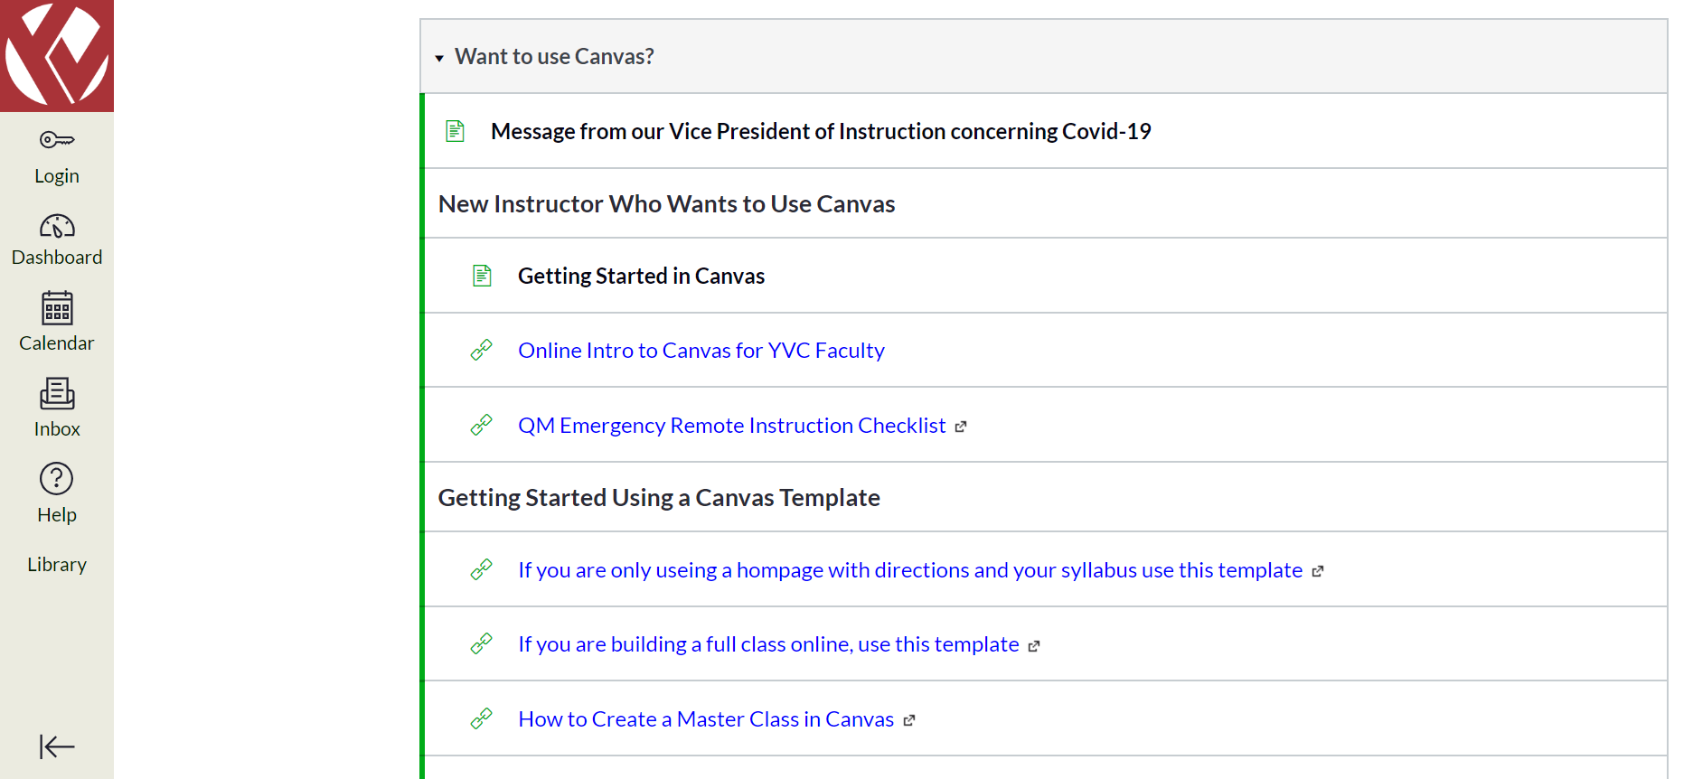

2021-2022 Divisional Committee Representatives

Divisional Committee Representatives are voted on during the Spring Division Meeting (except for the calendar committee).

Department Schedulers

Biology- Jerred Seveyka
English – Tracy Arostegui
Humanities – Chris Otten
Math – Ben Mayo
Nutrition – Sarah Panarello
Physical Sciences – Natalia Dunn
Social Sciences – Lois Sabol
You will work with your scheduler on the classes you will teach each quarter for the upcoming academic year. The schedulers will submit the schedules to the Program Support Supervisor 2 in the Dean’s office for the Dean’s approval. If you have any questions or concerns regarding your schedule please speak to your scheduler and/or your Department Head.

Observations and Student Evaluations

As new faculty, you are scheduled to undergo a course observation in Winter Quarter. Observations occur once every 5 years after the first two years. You will receive notifications before the start of the quarter that you will be observed during that quarter. The Dean’s office will coordinate a date and time with you for Kerrie to observe your class. Typically these are normal lecture days unless Kerrie has requested to observe a lab/other class activity. Notify Secretary Senior Vanessa Tucker in the Dean’s office if you need to reschedule your observation. After Kerrie observes your class, the Dean’s office will schedule a 30-minute meeting for you to meet with Kerrie and go over what she observed. In addition to the observations, self-evaluations are submitted to the Dean’s office for the first 2 years. Information on both the observations and self-evaluations can be found in your AFT-Y Faculty CBA.

In the past student evaluations were conducted on paper and staff went to every class to conduct and collect the evaluations. Currently, student evaluations are electronic and students are given a link to the survey. For the first 2 years, student evaluations are given for each class in each quarter taught. You will have an opportunity to discuss the results with Kerrie after you have received them, have had a chance to review them and after grades have been posted.

