Activate Your SoftChalk Account
To get started the first thing you need to do is activate your SoftChalk account using our activation key. Please follow the steps below.
- Go to the Join Now page of SoftChalk
  - In The Activation Key copy and paste the following key, make sure there are no spaces before or after the key: ZN71KvxzYO8eg2np5M4s
- Finish filling out the rest of the fields, you will need to create a username and password and can use your YVC email address.
- Please check both boxes at the end of the form accepting the terms of use and developers agreement.
- Press the Join button
- Remember to make a note of the username and password you set up. We do not have the ability to reset passwords; SoftChalk support must reset passwords.

SoftChalk Create Editor
The next step is to download the SoftChalk Create App to any computer where you will work in SoftChalk.
- Access the download page at, Get Started
- Campus computer may require you to turn in a request to the Tech Services Helpdesk. Log into your Faculty Portal and click the Help Desk icon.
- Determine if the device is 32-Bit, 64-Bit, or MAC, you can download the app to as many devices as needed.
- If you don’t know if your device is 32 or 64 Bit, Google how to find out for your device.
- Once you download the Create App, you will be prompted to sign into your SoftChalk Cloud account.
- After installing the app, you access it via a short-cut icon on your desktop. It is not required to log into the SoftChalk cloud online to use the app.

Working in SoftChalk Create Editor
- Once the Create app is installed, you can launch it from the icon on your desktop or from the SoftChalk Cloud.
  - From your desktop simply click the icon
  - From the SoftChalk Cloud, log in and click My Content, this will open the create app
- The create app works like a small word processor. The best way to learn how to use the tools is to explore their use. There are short videos available in your SoftChalk Cloud account, click the Support button once you log into your account.
- Download the Quick Start Guide

Setting up your Assignment in Canvas
Once your lesson is built, you can link it into a Canvas assignment where any activities will automatically add the score to the Canvas gradebook.
- Go to your SoftChalk Cloud account
  - Click My Content and then lessons
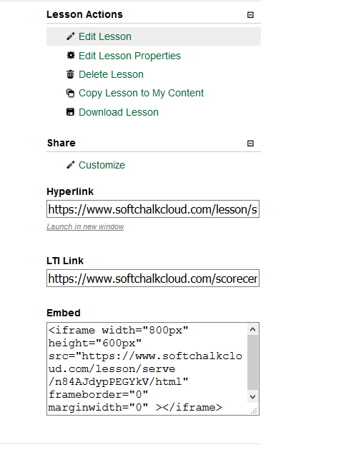
  - Find the lesson you want to link into Canvas, Under Actions click expand all if you do not see it right away.
  - Click the name of the lesson to open it in the window; it can also be edited here, but using the editor on your computer is easier
  - Using your browser scroll bar, scroll toward the bottom of the page, (not the lesson) to find the links you will need to copy into Canvas
  - Look for the link named, LTI Link, select the link content, press and hold the Ctrl button + the C key to copy the link.
- Go back to the browser tab where you Canvas Class is open.
  - If you do not have an Assignment for the SoftChalk lesson created, do so now
  - Access the Assignment and click Edit
  - Fill in the settings as you would like them
  - In the Submission Type drop-down select External Tool
  - Paste the link (Ctrl + P Key) into the Enter or find and External Tool URL box
  - Check to box under it to load in a new tab
  - Finally, save your changes to the assignment
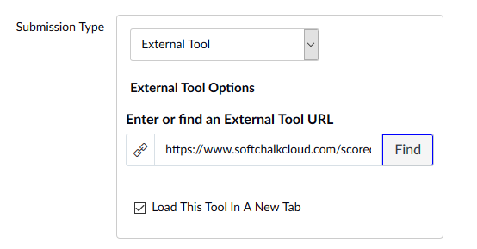

Score Center
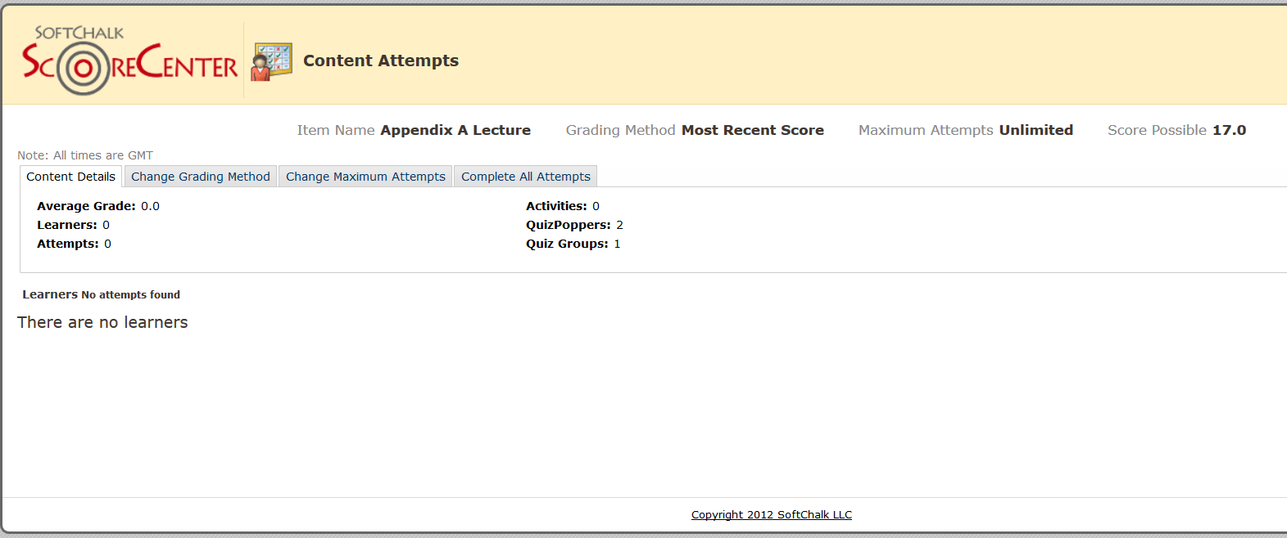
Finally, set up how you want the SoftChalk Score Center will handle the lesson. There are several tabs with settings you should review.
- Change Grading Method
  - The drop-down box in this setting is very important; lesson learned if you set to “Most Recent Score” if a student goes back in the lecture to review all scores will reset to zero if they do not do the activities again.
  - If you allow more than one try, recommend setting this field to Highest Score or Average.
- Change Maximum Attempts
  - This field can be set to unlimited up to 10 attempts
- Complete All Attempts
  - This field will mark every attempt for all learners as complete and allow for editing of grades.

